**Module 3**

**Name:** Upadhyay Sachin Naresh

**Batch id:** AIWDEOB 300821

**Topic:** Mathematical Foundations - Optimization

1. Find the maximum and minimum value of the function x3 - 3x2 - 9x + 12

**Solution:**

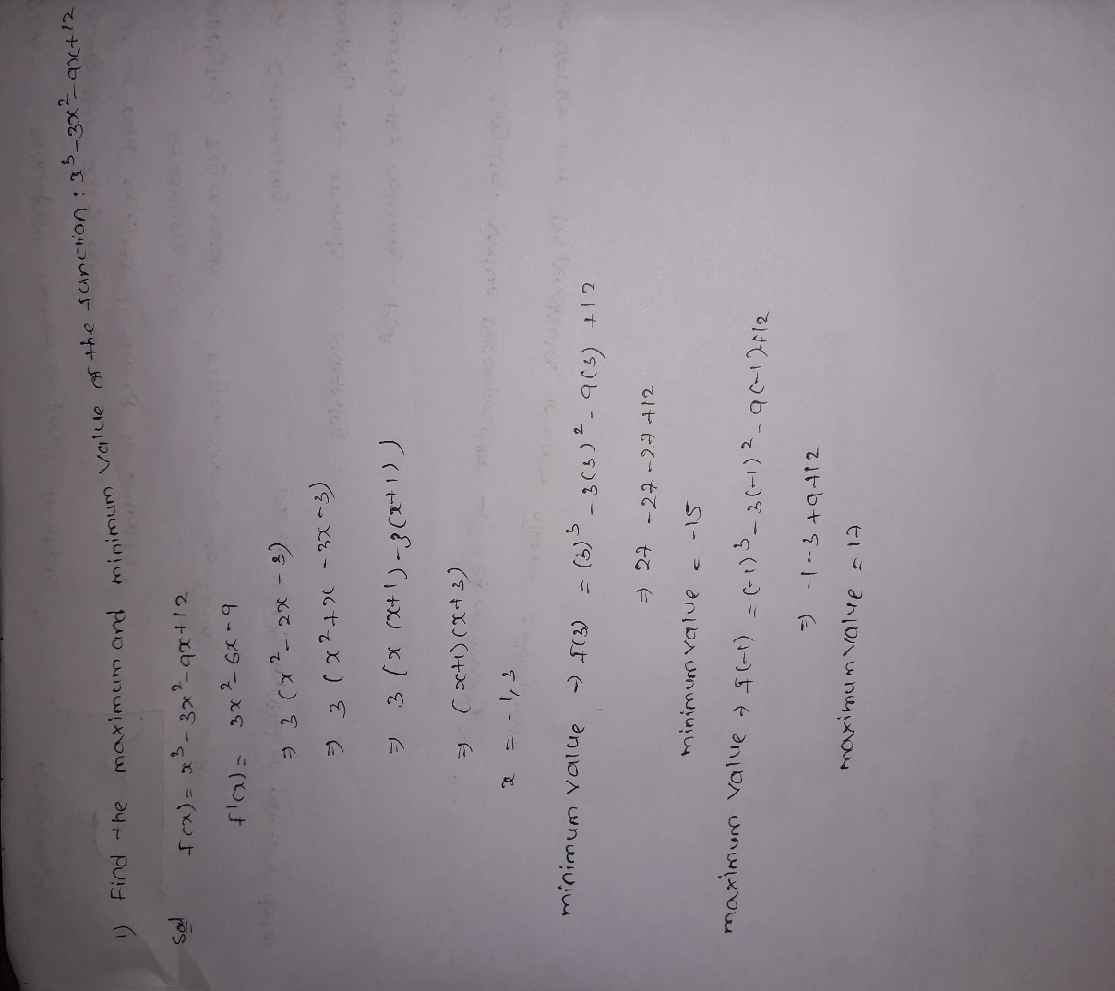

1. Calculate the slope and the equation of a line which passes through the points (-1, -1) (3,8)

**Solution:**

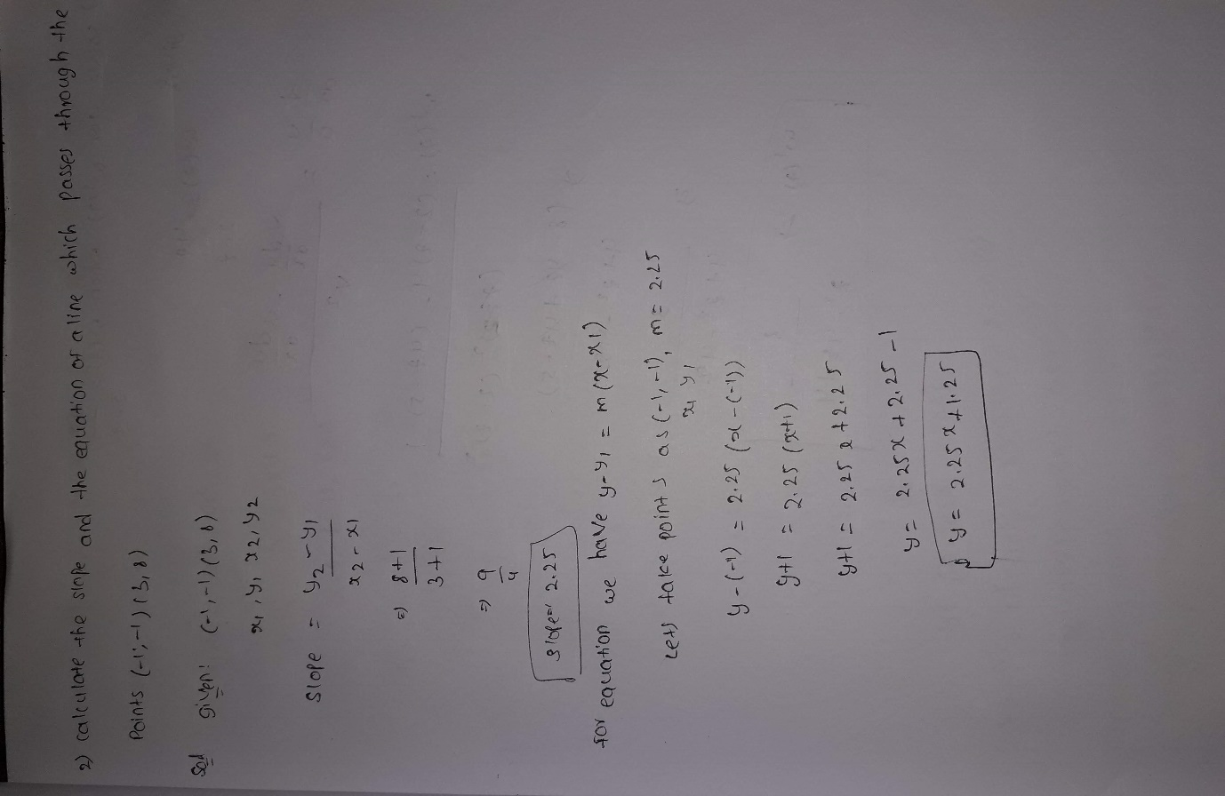

1. Solve for w’(z) when



**Solution:**

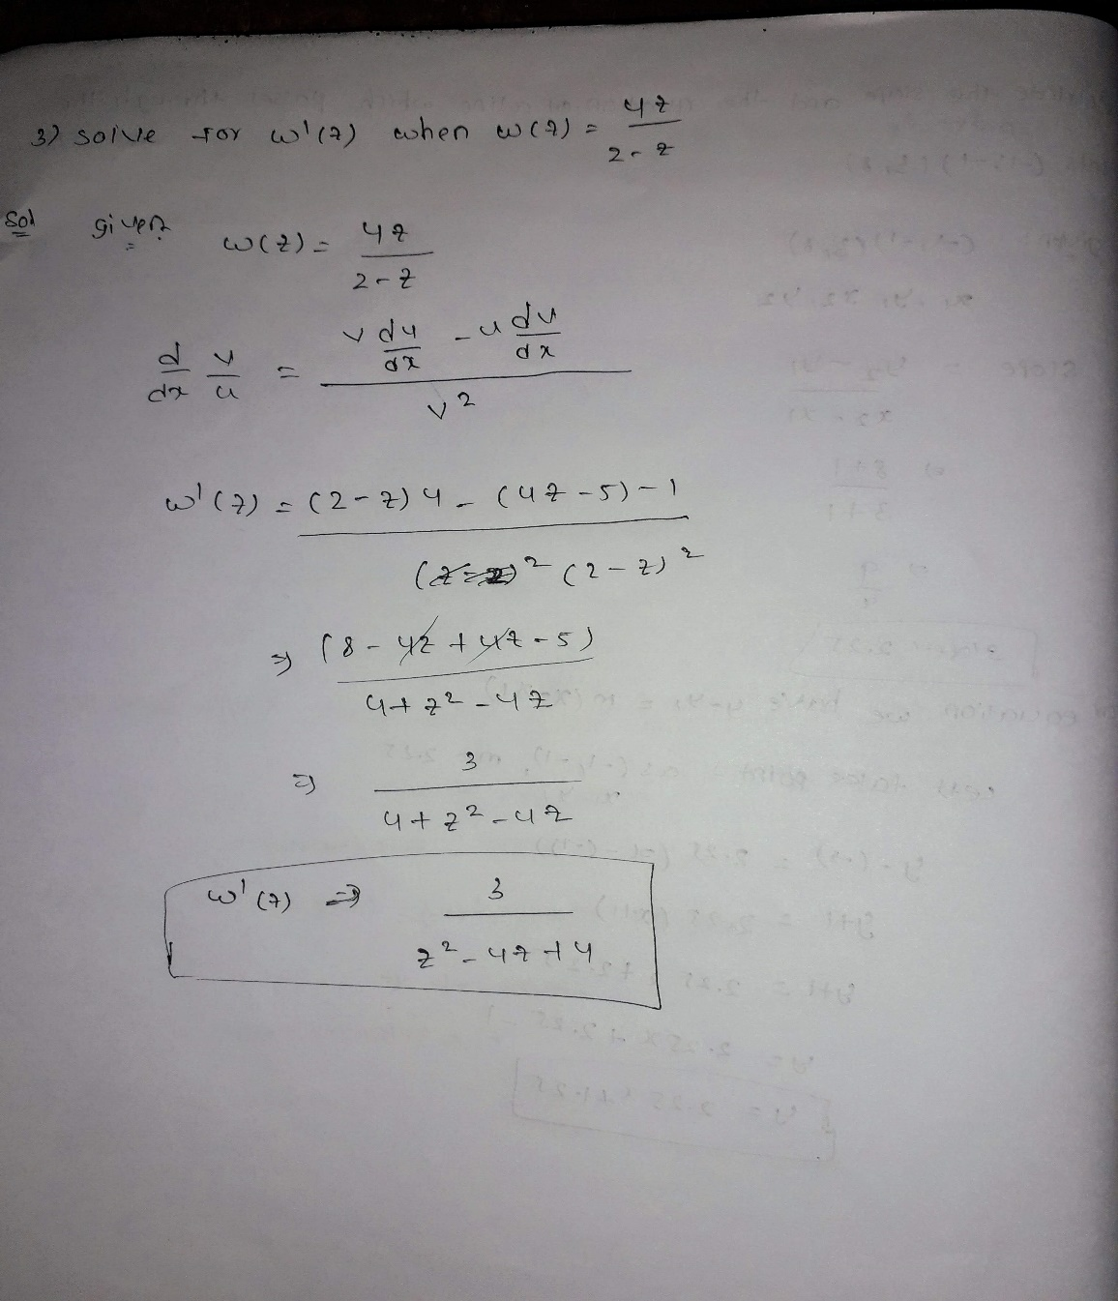

1. Consider Y(x)= $2x^{3}+6x^{2}+3x$. Identify the critical values and verify if it gives maxima or minima.

**Solution:**

Y(x) = 2𝑥3+6𝑥2+3𝑥 _________________ (1)

Y’(x) = 6x2 + 12x + 3 ____________________ (2)

Y” (x) = 12x + 12 _______________________ (3)

Critical points,

Putting Eqn (2) = 0,

Y’(x) = 6x2 + 12x + 3 = 0

Y’(x) = 2x2 + 4x + 1 = 0

x = -1(-1/ (1/√2)) or x = -1(+1/ (1/√2))

Maxima or Minima,

At x = -1(-1/ (1/√2)),

From eqn (3),

Y” (-1(-1/ (1/√2))) = 12 ( -1 / √2) < 0

Y(x) has maximum value at x = -1(-1/ (1/√2))

At x = -1(+1/ (1/√2)),

From eqn (3),

Y” (-1(+1/ (1/√2))) = 12 (+1 / √2) > 0

Y(x) has minimum value at x = -1(+1/ (1/√2))

1. Determine the critical points and obtain relative minima or maxima or saddle points of function f defined by



**Solution:**

Y = 2x 2 + 2x x + 2x 2 + 6x

1 1 2 2 1

∂y / ∂x1 = 4x1 + 2x2 + 6

∂y / ∂x2 = 2x1 + 4x2 Critical points,

∂y / ∂x1 = 0 and ∂y / ∂x2 = 0,

∂y / ∂x2 = 2x1 + 4x2 = 0 x1 + 2x2 = 0

x2 = - (1/2) x1

Substituting x2 in ∂y / ∂x1

∂y / ∂x1 = 4x1 + 2x2 + 6 = 0

= 4x1 + 2 (- (1/2) x1) + 6

= 4x1 – x1 +6 x1 = -2

Substituting x1 in x2 x2 = - (1/2) x1

x2 = - (1/2) (-2) x2 = 1

Critical points are, x1 = -2 and x2 = 1 Saddle Points,

f1 = ∂y / ∂x1 = 4x1 + 2x2 + 6

f2 = ∂y / ∂x2 = 2x1 + 4x2 Second order direct partials,

∂2y/∂x 2 = f = 4

1 11

∂2y/∂x 2 = f = 4

2 22

Second order Cross partials,

∂2y/∂x1∂x2 = f12 = 2

∂2y/∂x2∂x1 = f21 = 2

By using hessian determinant,

|H| = |𝑓11𝑓12 |

𝑓21𝑓22

|H| = |4 2|

2 4

|H| = 16-4 = 12 is Saddle point